Across the Borders

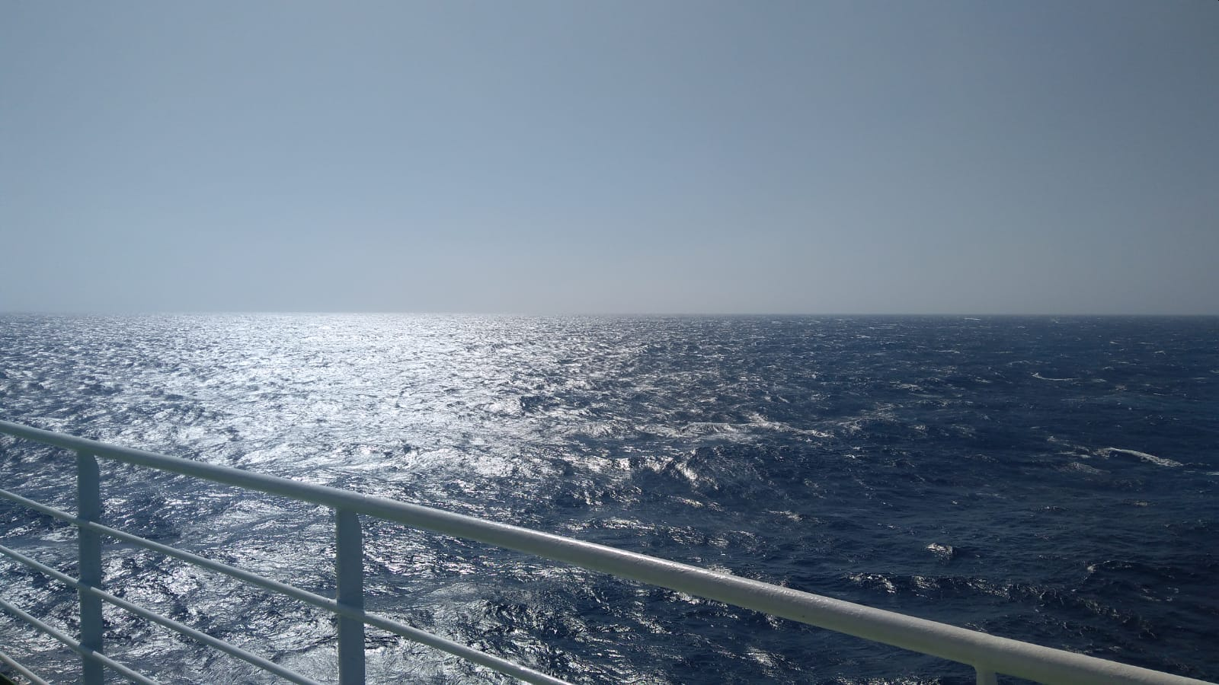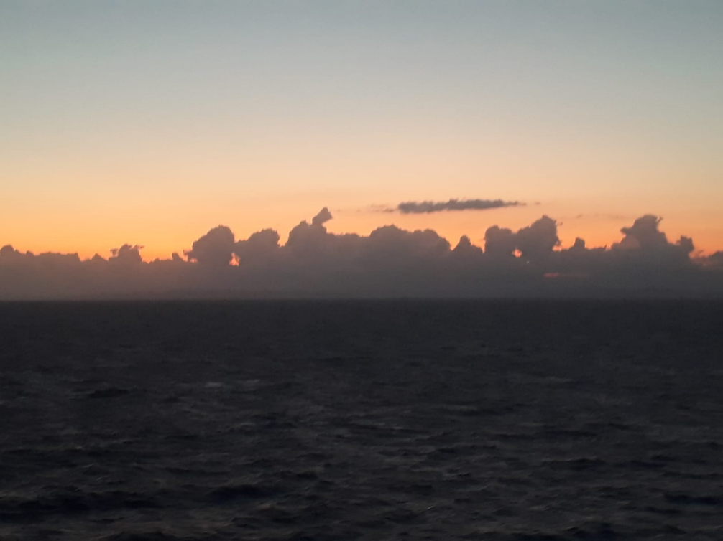

Here we see a picture of a beautiful sunset on the horizon. People always symbolize their goals to the Sun and stars so lets do the same here. Lets say the Sun is our goal. It is on the edge of the land and the sky, the possible and impossible. When we reach it we feel as we are the best, we came the furthest, we reached the impossible. But as we can see (or cant) our Sun is obstructed by clouds, the obstacles in our life - long journey. They are here to test us, ground us, guide us, and remind us to appreciate everything we have. Point is as long as we don’t see them as a bad thing we have partially already reached our goal, but once we get through all of it and finally reach it, it will make the skies shine a little brighter.

**********
"A border puts distance in the proximity"
Christophe Arbaret

Border is something that keeps us away from something. That something could be the best thing in your life, or the worst one. However i think people should cross them anyway, because if they don’t, how could you ever know what could have happened. If you try, you have nothing to lose. You can either be happier or learn something from that. And if you have just one border, you are probably unable to see something perfect right next to you.
**********

„Peace has no borders.“
Itzhak Rabin
That´s really so, peace has never had borders, it never will have. Peace is spread all over the world.What will the world and a world without peace do to us? We never need wars and bombing again. That is why we need peace, not only here, but also wherever wars are fought, any feuds. Without peace we have nothing. As if we didn´t exist.
**********

“Climate change does not respect border”
Ban Ki-moon
Climate change is a major problem for modern societies, as environmental changes can threaten food production, lead to rising sea levels and increase the possibility of disastrous flooding events. Unfortunately, many people, including politicians ignore the seriousness of this problem. Climate change is now affecting all regions around the world. But there is a way to solve it. Only we, people can fix this problem if we unite as one and go against it together.

**********
“Once a friend, always a friend. Why should borders stop that?”
-Erin Hunter
When we consider someone a friend he will always remain a friend regardless of distance. Many people have boundaries about friendship, in the past it was much worse, but today love is almighty. There are no boundaries in love and when we love someone we will do everything for that person and even cross some personal boundaries. Friends should not be condemned on the basis of appearance, because with this we only limit our worldview and choice for friends.
Nikolina Matković
**********
“The love of ones country is a splendid thing. But why should love stop at the border?”
Pablo Casals
Most people love their country, mores, habits and traditions. Everyone has their own lifestyle, everyone is connected to their home, friends and family. However, many are unhappy with life in their home country because of their difficult lives.. For this reason, quite a few people go beyond the borders of their home country seek better living conditions. Many people still have a hard time living in their own country, but they dont want to leave all what they have gained in their beautiful homeland!

Marko Novak

**********
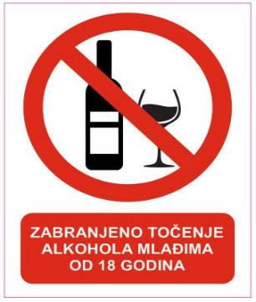

Teenagers and border in alcohol consumption
More and more teenagers (under 18 years old ) goes out in the late hours of the night, nightclubs and fun places to hang out with friends with consuming alcohol... The teenagers say they can relax more easily while consuming alcoholic drink. In Croatia, drinking alcohol under the age of 18 is prohibited, but as we can see from the pictures, this is just a law on paper and few adhere to it. The question now is whether the age border for teens is required? Are they allowed to drink alcohol legally 18 years ago?
**********

A border is a line that borders something. Everyone has their limits in their lives, sometimes they can bee god and sometimes bad, you don`t know until you break that border. It may seem impossible to us but, we are human, we can do anything. No matter where or how we live, all people on this planet live under the same sky, the same sun warms us, the same stars shines at night. Whether we are poor or rich, old or young, everyone is special but different again. Anyway one thing connects us, whether night or day, another time zone - the sky is one.
Ines Štivičić, 4.a

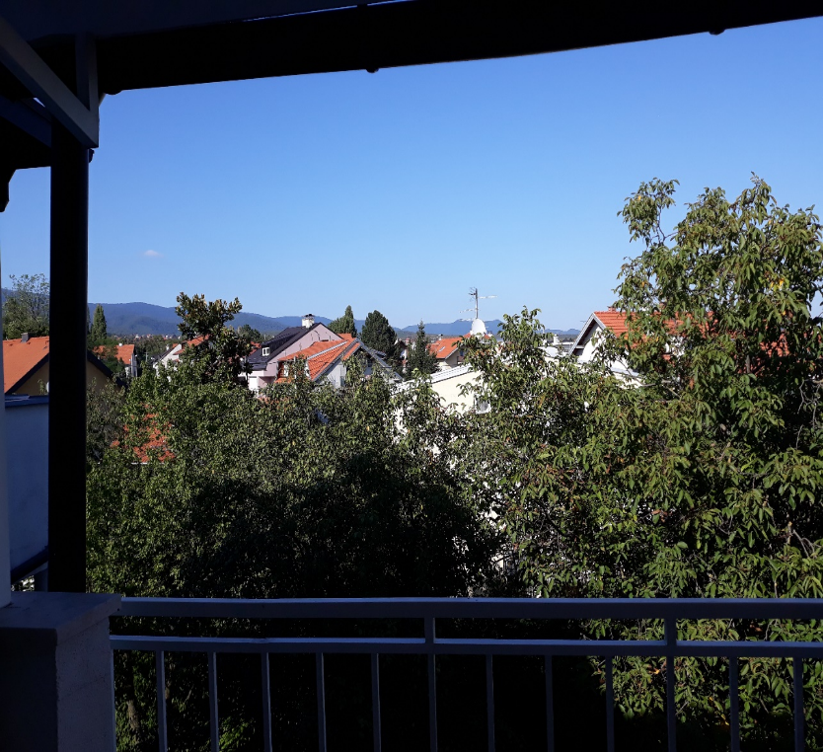

**********
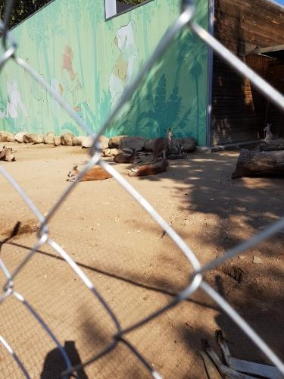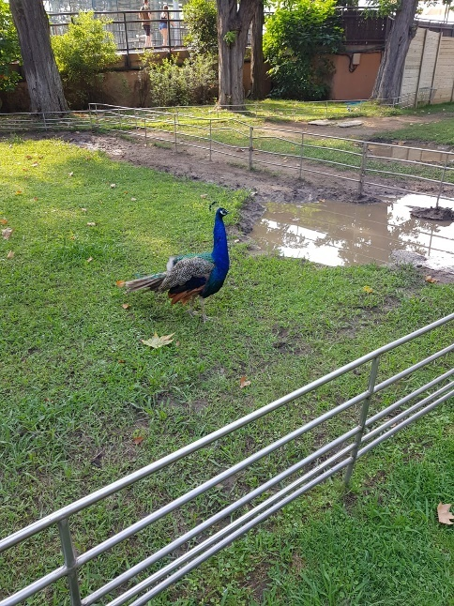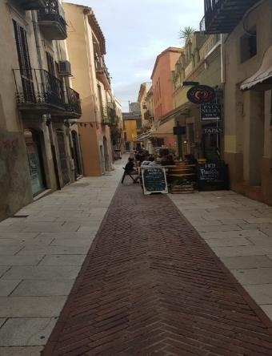

The border in political terms is actually a line dividing the territories of the two states. Each of us has our own border, sometimes that exact border does a terrible thing to us, because it makes it impossible for us to have different views of the world, but to limit ourselves, that border can ever cross and see the good things that will happen to us when we do it, but we need to be aware of the risks. But there are also some good boundaries that should not be crossed because some bad things can happen to us. Borders are all around us and we need to know how to respect and differentiate them.
Nikolina Matković

**********
"The boundaries are elementary linear structures that act on the three registers of the real, the symbolic and the imaginary." - Michael Foucher
To better understand these three registers we should imagine a game of chess. The game has its rules, every piece can make a certain move and the board itself is there for a purpose. They all represent the Symbolic. Every piece has its name which represents the Imaginary, and certain circumstances that are left out of past two registers are the Real.
If we move that analogy to the borders we can conclude that the "border" is very much a game of chess. It has it's name and place, where it is and where it isn't, the Imaginary, it also has its purpose, to divide, make an example of one or just to keep things in control, the Symbolic, but there also might be things that break the border, that keep on going through them no matter what, the Real.
Boundaries are all around us, some good some bad, to someone, a boundary can be a fear or a mental or physical state, or maybe a physical thing keeping them from seeing their loved ones, but boundary can also be law or a rule keeping us safe or everyone in check. What i think was trying to be said in this quote is that we should always try and give our best in breaking the bad ones.
Marko Verić
**********
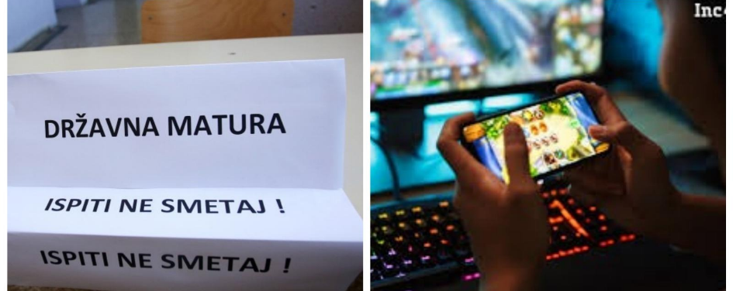
"To study or not to study that's the question" – Božo Plazanić
So this year is the most important year of our graduate's lives. On the date 22.05. we decide whether we take this education on to the next level or we go into the life of regular job 9-5. On the left side, we can see preparations for a final examination and on the right our joy and there is you the little human whose life is divided between these two things. (:

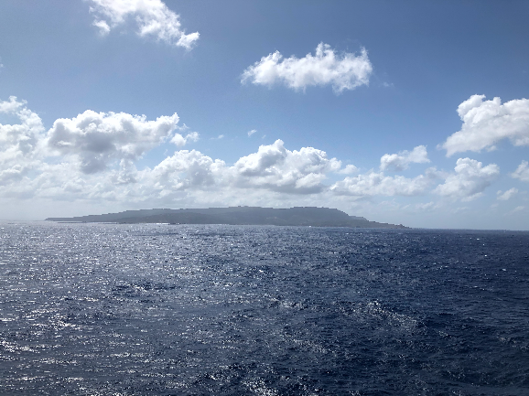

We all live under the same sky, but we do not all have the same horizon. The horizon changes as we move, the horizon associated with the curvature of planet Earth. This means that what's on the horizon may be partially hidden. So we need to step out of our comfort zone and explore the things the world has to offer.
Borna Županić

